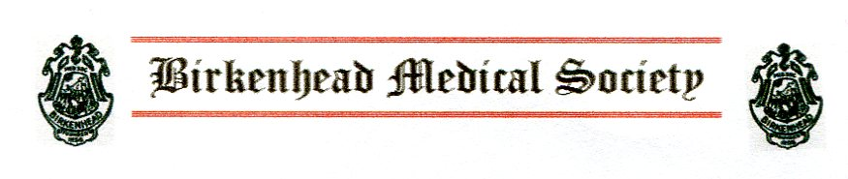
Professor Louise Kenny CBE MD PhD MRCOG
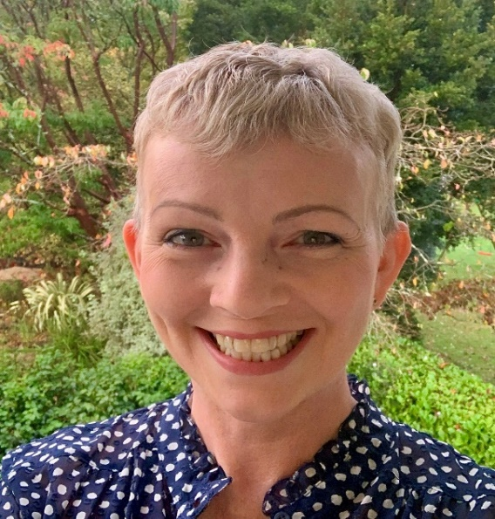
Executive Pro-Vice-Chancellor Faculty of Health & Life Sciences
“The importance of celebrating failure in medical research”
We welcome Louise as our after-dinner speaker. Graduating from Liverpool Medical School in 1994 with honours, she pursued a career in obstetrics and gynaecology which took her to Nottingham and Cork Universities before returning to her hometown in 2018. Her main research interest was hypertension in pregnancy. With over 300 published original papers and as the lead Investigator of the Wellcome Trust funded programme “Children Growing Up in Liverpool”, she is well versed in both success and failure in medical research.
VENUE: Thornton Hall Hotel, Thornton Hough (Cristal Suite)
DATE: Tuesday 28th March 2023
TIME: 7:00 for 7.25pm
COST:£35 per guest - Includes 3 course dinner, wine, coffee & mints
To attend please email- Dr Chris Brace at birkenheadmedicalsociety@ggmail.com for further details

Next meeting: Wednesday 26 April AGM
23rd May “From Admiral to x- rays. A walk along Rodney Street”- a talk by Marie Passey (Blue Badge Guide)
17th October Presidents Dinner with Prof Tim Jones (VC Liverpool University)
website https://tinyurl.com/BMS1856

