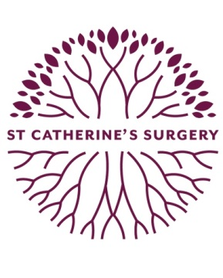

Salaried GP Vacancy – St Catherine’s Surgery

We are seeking a salaried GP to join our friendly, supportive team of 7 Partners and 5 Salaried GPs for 6-8 sessions per week (would consider job-share); we place great emphasis on teamwork and are seeking a candidate who is willing to participate fully in all aspects of surgery life. The Practice is based within modern purpose built premises hosting a variety of community services including: District Nurses; Cardiology; Physiotherapy and X-ray department.

About The Practice:

- Patient list size 15,200
- Part of Brighter Birkenhead Primary Care Network
- High QOF achievers, and CQC “Good” in all areas
- Training Practice with GPSTs / Medical Students / Student Nurses
- Supportive Practice with each Salaried GP allocated a mentor (Partner)
- Informal daily meetings facilitating peer support / case review

Closing Date: Friday 22nd October.

If you are interested:

For an informal chat or to arrange a visit to the practice, please contact Paul Warren, Business Manager on 0151 643 6700 or paul.warren2@nhs.net

To apply:

Please send a CV and covering letter to the following address (or email paul.warren2@nhs.net):

Paul Warren, Business Manager
St Catherine’s Surgery
Second Floor, St Catherine’s Health Centre
Church Road, Birkenhead
Merseyside, CH42 0LQ

