KINGS LANE MEDICAL PRACTICE
Dr D Kershaw MB ChB FRCGP

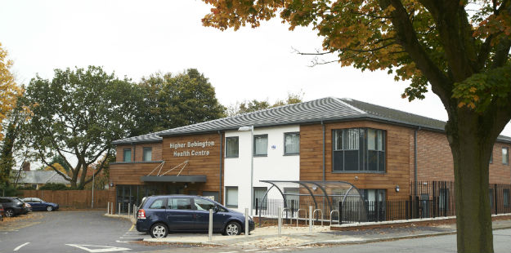
Higher Bebington Health Centre,
25 Brackenwood Road,
Higher Bebington,
Wirral, CH63 2LR

Tel: 0151 608 4347
Fax: 0151 608 9095
www.kingslane.net

Salaried GP Vacancy: 4-6 sessions per week (temporary contract)
We are looking to recruit a GP for a fixed term contract until end of March 2021. There is a possibility this may be extended / made permanent.
With a list size of 5000 patients, we are based in a purpose built health centre in South Wirral.
In addition to GP’s the practice…
- Consists of a team of 2 Practice Nurses, a GP Assistant and Phlebotomist.
- Is supported by friendly, professional reception and administration teams
- Achieves consistently high QOF outcomes
- Use EMIS Web and Docman systems
- Achieved ‘Good’ overall by CQC (Inspection date: April 2016)
For further information or to arrange an informal visit, contact Robbie Howard, Practice Manager on 0151 608 4347 or by email: robhoward@nhs.net
Closing Date for applications: 30 September 2020

