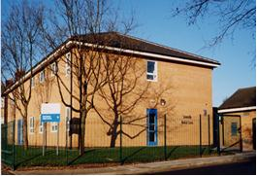 | Somerville Medical Centre  Dr P Wilson Dr S Evans Dr H Halder  69 Gorsey Lane  Wallasey  CH44 4AA
 | 1515 638 9333

Band 5 Practice Nurse 16 hours per week

We are looking for an enthusiastic and motivated Treatment Room Nurse to join our team to provide a range of practice nursing duties. (See attached Job Descriptions).

To work as part of our Team of 6 Doctors, 2 Practice Nurses ,2 Nurse Specialists 1 HCA supported by Experienced Admin and Reception Team providing excellent service to our diverse & friendly practice population of 8725

Applicants must hold current NMC registration.

Please send applications to: Practice Manager anita.swift@nhs.net

Closing Date 26th June 2020.

