St Hilary Group Practice

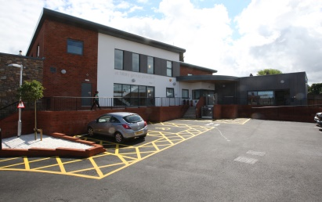 Salaried GP vacancy
6-8 sessions per week

We are looking for a Salaried GP to join our well established and forward thinking diverse team with a potential view to Partnership.

The candidate should be a motivated, hardworking GP who is willing to participate fully in all aspects of the practice providing an excellent service for patients whilst maintaining a good work life balance.

The Practice
- Based in purpose built premises in Wallasey very close to M53 motorway and Mersey tunnel
- Patient list size 5800
- CQC “Good” in all areas with “outstanding” area
- High QOF achiever
- Clinical system EMIS web and Docman10
- Long established training practice for Registrars, F2 doctors and 3rd year Medical Students (Liverpool University)
- Very closely involved with PCN and GP Federation
- We hold daily lunchtime clinical meetings

Practice Team

- 4 GP Partners
- 2 Practice Nurses and 2 HCAs (one is also our phlebotomist)
- Clinical Pharmacist one day a week
- Employed counsellor
- Experienced admin and reception team

For an informal chat or to visit the practice please contact Monika Doyle, Practice Manager
0151 638 2216 or e-mail: monika.doyle@nhs.net

To apply:
Please send your CV and covering letter to monika.doyle@nhs.net or to the following address:
St Hilary Group Practice
Broadway
Wallasey, Wirral
CH45 3NA

Closing date: 29th November 2019

