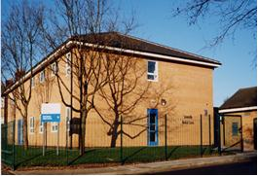 | Somerville Medical Centre  Drs. Wilson, Evans, Halder, Costello, Dufton & Thompson  69 Gorsey Lane. Wallasey, CH44 4AA  E-Mail: WICCG.gatekeepern85024@nhs.net  Tel: 0151 638 9333

IT – Data Manager Full Time Post

Hourly Rate £9.50 - £10.00 per hour depending on experience

IT – Data Manager required join our team @ Somerville Medical Centre

Busy Practice of 8,500 Patients applicant must have experience of NHS and EMIS systems

Please see Job Spec / Job Description attached

Email CV and covering letter to

Practice Manager anita.swift@nhs.net

Deputy Practice Manager Ali.neilson@nhs.net

