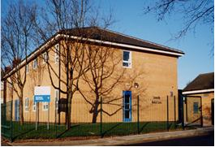 | Somerville Medical Centre  Drs. Wilson, Evans, Halder, Costello, Dufton & Thompson  69 Gorsey Lane. Wallasey, CH44 4AA  E-Mail: WICCG.gatekeepern85024@nhs.net  Tel: 0151 638 9333

Part Time Health Care Assistance Level 3/4

16 hours per week

We are looking for an enthusiastic and motived HCA to join our friendly team to provide a range of HCA duties

Duties to include

- Venepuncture
- New patient Health Checks
- Wound Care
- ECG

Rates of pay are dependent on experience Job Description attached

Please send CV application and covering letter to:

Practice Manager Mrs Anita Swift anita.swift@nhs.net

Closing date 30th August 2019

